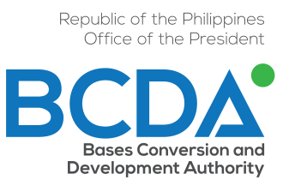
BCDA-PROCD2015-06
January 2015

INTEGRITY PLEDGE
BCDA Merchant

We believe that corruption has been one of the biggest impediments to economic growth and prosperity in the Philippines and has been eroding the moral fiber of our society.

We recognize that the current administration, in particular the Bases Conversion and Development Authority (BCDA) leadership, is taking initiatives to promote integrity and uphold anti-corruption principles in the conduct of its business and in its interaction with its business partners and the public in general.

We realize that such initiatives will not succeed without our full cooperation and support.

As professionals, business owners, and development partners, we are fully aware of our responsibility to our stakeholders and to society to conduct our business with the highest degree of professionalism and ethical standards.

Wherefore, we hereby pledge the following:

- We will promote healthy competition and will not engage in collusion and rigging that make a mockery of the bidding process.
- We will provide value-for-money services by including in our bid offers only the costs directly related to the project with reasonable profit, and by implementing the contract in accordance with agreed upon obligations, deliverables, and quality standards.
- We will not engage in corruption or bribery involving cash or in any form and we will not offer or yield to any demand or request for illegal or illicit transactions.
- We will maintain only one book of accounts and we will ensure that our financial reports are accurate and transparent.
- We will install internal controls and systems improvement to promote good governance, accountability, and transparency.
- We will ensure that our employees embrace our commitment to integrity by developing or enhancing our internal Code of Conduct and Ethical Standards.
- We will create a business environment that is free from corruption.
- We will continue to participate in dialogues with BCDA and fellow merchants to address any concerns in a fair and transparent manner.

Name and signature

Position

Company

Date signed

